**Tetris**

▪ PCs (first made for the Elecronica 60 then published by Spectrum HoloByte for Commodore 64 and IBM PC before expanding to arcade handheld and consoles through various companies worldwide.)  
▪ All ages  
▪ June 6, 1984 (first playable version, only distributed in Russia)

**Game Outline**

A random sequence of Tetriminos fall down the playing field. The objective of the game is to manipulate these Tetriminos, by moving each one sideways and rotating it by 90 degree units, with the aim of creating a horizontal line of ten units without gaps. When such a line is created, it gets destroyed, and any block above the deleted line will fall.

**Characters**

Tetriminos are game pieces shaped like tetrominoes, geometric shapes composed of four square blocks each.

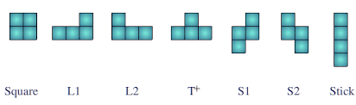

**Gameplay**

The original version had only one infinite level, later versions have levels that get progressively faster to make the game more challenging.

**Game World**

The playing field started and in many versions remains a vertical black rectangular field or shaft, known to players as the well or matrix.

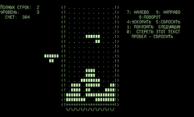 This is an image of the screen from the Russian game

 This is a screen from an early western release, it may seem a little more familiar.

**Game Experience**

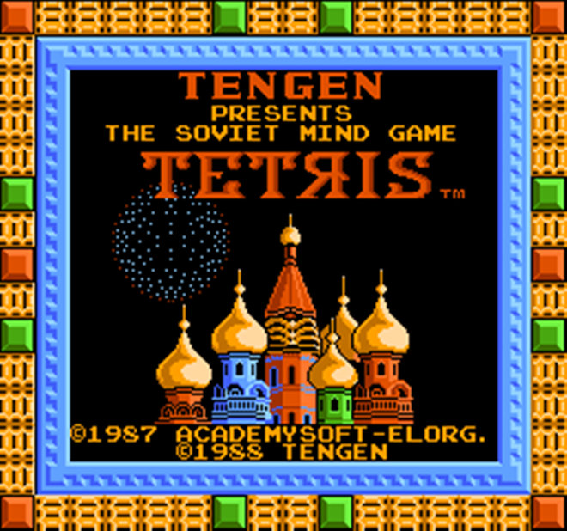  
When the Game was released in the west it had graphics from famous Russian architecture on the box and title screen, but the original simply started with a black screen

The original had no sound

**Gameplay Mechanics**

Fill in full lines, if the pieces reach the top of the playing field its game over, start from scratch.  
  
**Multiplayer and Bonus Materials**

A number of later versions have a 2 player option but the original did not

**Monetization**

Purchase price for game disc/cartage for pc and consoles, quarters for time/lives on the arcade version